Practical no. 1: Preparing the IoT Hardware
- Set up Raspberry Pi OS / Arduino IDE
- Configure GPIO settings and test basic connectivity
- Demonstrate pin layout and onboard peripherals

- Set up Raspberry Pi OS / Arduino IDE

Part A – Setting Up Arduino (Using Tinkercad or Hardware)

In Tinkercad (Virtual Setup)
- Open Tinkercad Circuits → Log in or sign up.
- Click Create New Circuit.
- Drag and drop:
  - Arduino Uno board
  - LED
  - Resistor (220Ω)
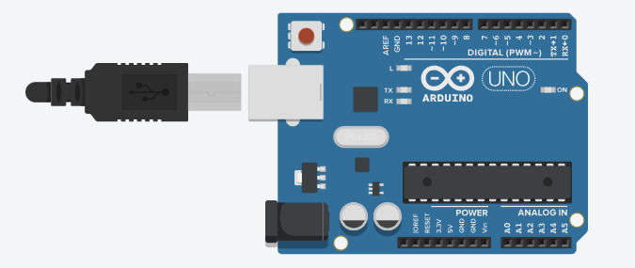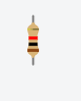

- Connect:
  - LED anode (+) → Pin 13
  - LED cathode (–) → GND
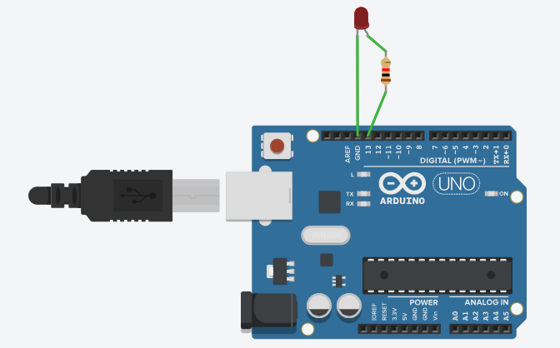

- Click Code → Text and write:
void setup() {
pinMode(13, OUTPUT);
}
void loop() {
digitalWrite(13, HIGH);
delay(1000);
digitalWrite(13, LOW);
delay(1000);
}
- Click Start Simulation.
The LED blinks every second, showing correct GPIO output control.
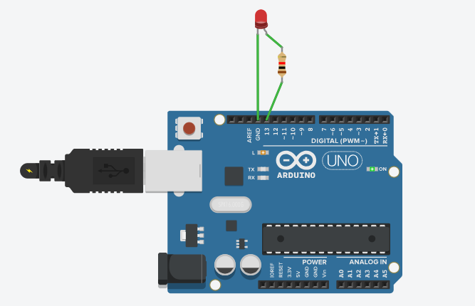

Part B. Setting Up Raspberry Pi OS (Hardware Only)
- Download and install Raspberry Pi Imager on your computer.
- Insert microSD card → Open Raspberry Pi Imager.
- Select:
  - Operating System: Raspberry Pi OS (32-bit)
  - Storage: Your microSD card
- Configure:
  - Wi-Fi, SSH, and username/password
- Click WRITE → Wait until process completes.
- Insert SD card into Raspberry Pi → Connect keyboard, mouse, monitor, and power.
- Complete setup wizard on first boot.
Raspberry Pi is now ready with OS installed.

- Configure GPIO settings and test basic connectivity
- Connect an LED between:
- GPIO17 (Pin 11) → Resistor → LED → GND (Pin 6)

- Open terminal and enter:
gpio -g mode 17 out
gpio -g write 17 1 # Turn ON
gpio -g write 17 0 # Turn OFF

LED turns ON/OFF — confirming GPIO works.
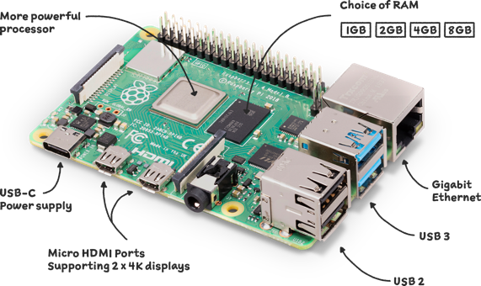

- Demonstrate pin layout and onboard peripherals.

1. Arduino Uno Pin Layout and Peripherals
- Arduino Uno is a microcontroller board based on the ATmega328P.
- It has multiple digital and analog I/O pins, power pins, and built-in peripherals used to connect sensors, actuators, and other devices.

Pin Categories:
Pin Type | Pin Numbers | Description / Purpose
Digital Pins | 0–13 | Used for digital input or output (HIGH/LOW). Example: controlling LEDs or reading switches.
Analog Pins | A0–A5 | Used for reading analog sensor values (e.g., temperature, light, potentiometer). Converts analog voltage to digital values using the ADC (10-bit).
PWM Pins | ~3, 5, 6, 9, 10, 11 | Provide Pulse Width Modulation output to control motor speed or LED brightness.
Power Pins | 3.3 V, 5 V, GND | Used to power sensors and other low-power components.
Reset Pin | RESET | Resets the microcontroller to restart the program.
Built-in LED | Pin 13 | Useful for testing; blinks during the Blink program.

Onboard Peripherals:
Peripheral | Description
USB Port | For uploading code and serial communication with a computer.
Power Jack | Provides external 7–12 V supply if USB is not used.
Crystal Oscillator (16 MHz) | Keeps the microcontroller’s clock timing accurate.
Voltage Regulator | Converts input voltage to stable 5 V/3.3 V.
ATmega16U2 Chip | Acts as a USB-to-serial converter for communication.

2. Raspberry Pi Pin Layout and Peripherals
- Raspberry Pi is a single-board computer with a 40-pin GPIO header.
- It supports digital I/O, communication protocols (I²C, SPI, UART), and includes various built-in hardware interfaces.

GPIO Header Layout
The Raspberry Pi GPIO header has 40 pins, including:
- 26 GPIO pins (programmable for input/output)
- Power pins: 3.3 V, 5 V
- Ground pins (GND)
- Special-purpose pins for communication protocols
Type | Example Pins | Purpose
Power Pins | 3.3 V (Pin 1, 17), 5 V (Pin 2, 4) | Power external sensors and circuits.
Ground Pins | Multiple (e.g., Pin 6, 9, 14) | Common ground connection.
GPIO Pins | GPIO 2 – GPIO 27 | General-purpose digital I/O for LEDs, switches, etc.
UART (Serial) | GPIO 14 (TX), GPIO 15 (RX) | For serial communication with microcontrollers.
I²C | GPIO 2 (SDA), GPIO 3 (SCL) | For sensor communication (e.g., accelerometer, RTC).
SPI | GPIO 10 (MOSI), GPIO 9 (MISO), GPIO 11 (SCLK) | For high-speed data exchange with sensors/displays.

Onboard Peripherals:
Peripheral | Description
HDMI Port | Connects to display or monitor.
USB Ports | Connects keyboard, mouse, or storage devices.
Ethernet Port | Provides wired internet connectivity.
Audio Jack | Output for speakers or headphones.
Wi-Fi & Bluetooth | Wireless connectivity for IoT applications.
Camera Interface (CSI) | Connects Pi Camera for image/video processing.
Display Interface (DSI) | Connects Raspberry Pi Touch Display.
MicroSD Slot | Holds operating system and storage.

